Low Level Design

# Amazon Sales Data Analysis

|  |  |
| --- | --- |
| **Written By** | Rajnish Ranjan Sinha |
| **Document Version** | 0.3 |
| **Last Revised Date** |  |

**DOCUMENT CONTROL**

## Change Record:

|  |  |  |  |
| --- | --- | --- | --- |
| **VERSION** | **DATE** | **AUTHOR** | **COMMENTS** |
| 0.1 | 30- March -  2023 | Rajnish Ranjan Sinha | Introduction and architecture defined |
| 0.2 | 30- March -  2023 | Rajnish Ranjan  Sinha | Architecture & Architecture description appended and  updated. |
|  |  |  |  |
|  |  |  |  |

**Reviews:**

|  |  |  |  |
| --- | --- | --- | --- |
| **VERSION** | **DATE** | **REVIEWER** | **COMMENTS** |
| 0.2 | 01- April -  2023 | Author 3 | Unit test cases to be added |

**Approval Status:**

|  |  |  |  |  |  |
| --- | --- | --- | --- | --- | --- |
| **VERSION** | **REVIEW**  **DATE** | **REVIEWED BY** |  | **APPROVED BY** | **COMMENTS** |
|  |  |  |  |  |  |

**Contents**

1. **Introduction 04**
   1. **What is Low-Level Design Document? 04**

|  |  |  |
| --- | --- | --- |
| **1.2** | | **Scope 04** |
| **2.** | **Architecture 05** | |
| **3.** | **Architecture Description 07** | |
|  | **3.1** | **Data Description 07** |
|  | **3.2** | **Web Scrapping 09** |
|  | **3.3** | **Data Transformation 09** |
|  | **3.4** | **Data insertion into database 09** |
|  | **3.5** | **Connection with SQL server 09** |
|  | **3.5** | **Export Data from database 12** |
|  | **3.6** | **Deployment 12** |
| **4.** | **Unit** | **test cases 15** |

1. **Introduction**
   1. **What is Low-Level design document?**

The goal of the LDD or Low-level design document (LLDD) is to give the internal logic design of the actual program code for the House Price Prediction dashboard. LDD describes the class diagrams with the methods and relations between classes and programs specs. It describes the modules so that the programmer can directly code the program from the document.

## Scope

Low-level design (LLD) is a component-level design process that follows a step-by-step refinement process. The process can be used for designing data structures, required software architecture, source code and ultimately, performance algorithms. Overall, the data organization may be defined during requirement analysis and then refined during data design work.

# Architecture

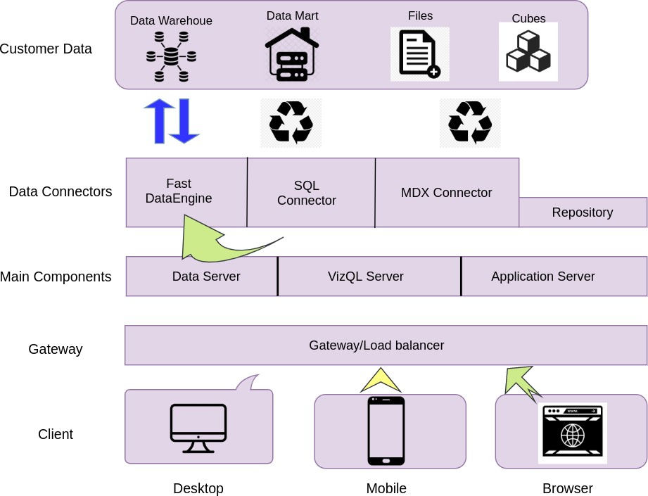

**Tableau Server Architecture**

Tableau has a highly scalable, n-tier client-server architecture that serves mobile clients, web clients and desktop-installed software. Tableau Server architecture supports fast and flexible deployments.

The following diagram shows Tableau Server’s architecture:

### Shape Description automatically generated with low confidenceLOW LEVEL DESIGN

**6**

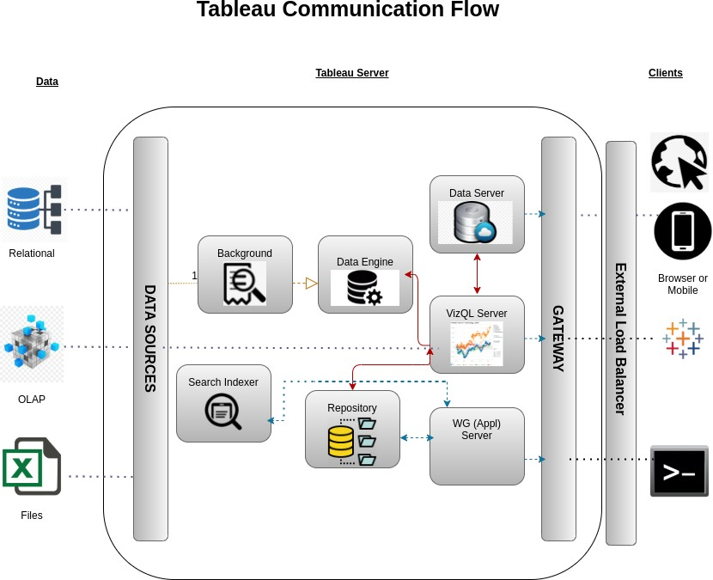

Tableau Server is internally managed by the multiple server processes.

**1. Gateway/Load Balancer**

It acts as an Entry gate to the Tableu Server and also balances the load to the Server if multiple Processes are configured.

**2) Application Server:-**

Application Server processes (wgserver.exe) handle browsing and permissions for the Tableau Server web and mobile interfaces. When a user opens a view in a client device, that user starts a session on Tableau Server. This means that an Application Server thread starts and checks the permissions for that user and that view.

1. **Repository:-**

Tableau Server Repository is a PostgreSQL database that stores server data. This data includes information about Tableau Server users, groups and group assignments, permissions, projects, data sources, and extract metadata and refresh information.

1. **VIZQL Server:-**

Once a view is opened, the client sends a request to the VizQL process (vizqlserver.exe). The VizQL process then sends queries directly to the data source, returning a result set that is rendered as images and presented to the user. Each VizQL Server has its own cache that can be shared across multiple users

1. **Data Engine:-**

It Stores data extracts and answers queries.

1. **Backgrounder:-**

The backgrounder Executes server tasks which includes refreshes scheduled extracts, tasks initiated from tabcmd and manages other background tasks.

1. **Data Server:-**

Data Server Manages connections to Tableau Server data sources

It also maintains metadata from Tableau Desktop, such as calculations, definitions, and groups.

1. **Architecture Description**
   1. **Data Description**

The Amazon sales dataset contains information about sales of various items in different regions and countries across the globe. The dataset includes details such as the region and country where the sale was made, the item type, sales channel, order priority, order date, order ID, ship date, units sold, unit price, unit cost, total revenue, total cost, and total profit. The dataset provides insights into sales trends, regional preferences, and profitable items for Amazon. It can be used by businesses to make informed decisions about their inventory and sales strategy.

## Web Scrapping

Web scraping is a technique to automatically extract content and data from websites using bots. It is also known as web data extraction or web harvesting. Web scrapping is made simple now days, many tools are used for web scrapping. Some of python libraries used for web scrapping are Beautiful Soup, Scrapy, Selenium, etc.

## Data Transformation

In the Transformation Process, we will convert our original datasets with other necessary attributes format. And will merge it with the Scrapped dataset.

## Data Insertion into Database

1. Database Creation and connection - Create a database with name passed. If the database is already created, open the connection to the database.
2. Table creation in the database.
3. Insertion of files in the table

## Make the SQL connection and set up the data source

**Step 1: Configuring Tableau**

Launch Tableau on your workstation and select SQL Server from the connect column on the left. This will open a dialogue box where you need to provide the connection details for SQL Server.

To connect with tableau, you will need to provide information about the server which hosts your database. If you want to connect to a contained database, you can also specify the name of the database.

To connect with a port other than the default port, you need to specify the port and server as follows:

<server_name><port_number>

Example query: my_server 8051

There are two ways in which you can sign-in to the server, either by using Windows authentication or by using the username and password. Using the username and password becomes a must if you’re working with a password-protected server in a non-Kerberos environment.

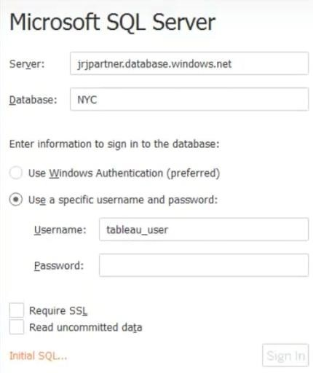

Click on Sign in to establish a connection. This will enable a connection without SSL. To establish an SSL enabled connection, click the Require SSL checkbox before you sign in.

SQL Server provides an option to let the user queries access the modified rows even before they have been committed. This option is called Read Uncommitted data. It saves time by preventing complex queries such as extract refreshes from locking the database and causing a delay. If this option is unchecked, Tableau makes use of default isolation levels.

If you want to run a specific SQL command every-time a new connection is established, you can use the Initial SQL option. This will open a dialogue box, where you can specify your desired SQL query.

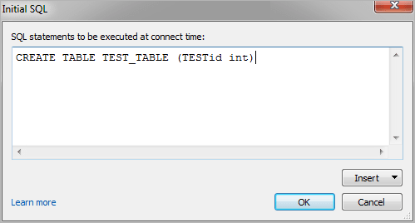

**Step 2: Configuring Data Source**

The data source page loads up after configuring the Tableau connector and successfully signing in. This is how the page looks like:

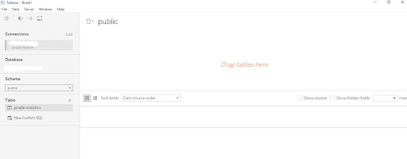

Select the data source name option and give a unique name to the database you are using. It’s considered a good practice to have a unique name as it makes it much easier for users to identify the database from which data is being fetched.

To select the desired schema, you can use the schema drop-down list from the column on the left. You can also perform a text-based search to find the desired option. Now similarly find and select the desired table and drag it onto the canvas.

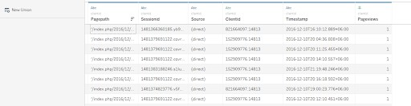

This is how you can connect SQL Server with Tableau. Now click on the sheets tab to begin the analysis.

Custom SQL features can be used to focus on specific SQL statements, rather than querying the entire database. Click on the Custom SQL option from the panel on the left. A new dialogue box will now open up, where you can provide the query you want to execute.

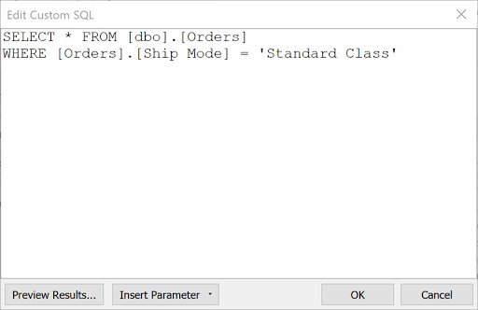

## Export Data from Database

Data Export from Database - The data in a stored database is exported as a CSV file to be used for Data Pre-processing.

## Deployment.

Here in the below screenshot, we can see that out workbook has been published to Power BI Desktop.

### Shape Description automatically generated with low confidenceLOW LEVEL DESIGN

**12**

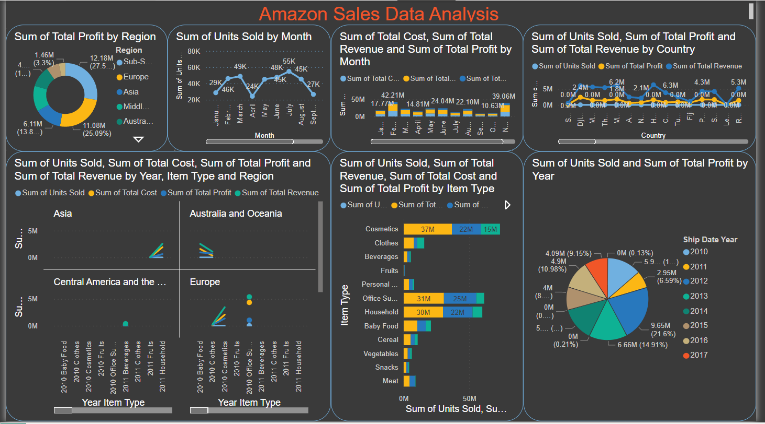

Here in the below screenshot, we can see that out workbook has been published to Power BI Desktop.

**13 LOW LEVEL DESIGN**

# Unit Test Cases

|  |  |
| --- | --- |
| **TEST CASE DESCRIPTION** | **EXPECTED RESULTS** |
| Sum of Total Profit by Region | When clicked on the Donut chart section it will show the Region with its corresponding Profit. |
| Sum of units sold by month | When clicked on the line chart it will show the relationship between unit sold month wise. |
| Sum of total cost, revenue and profit by month | Here a stacked bar graph which will show variation of cost, revenue, profit by month. |
| Sum of units sold, profit, revenue by country | When clicked on the line chart it will show variation of cost, revenue, profit by country. |
| Sum of units sold total cost, revenue and profit by year with item type and region | The visual should show a line graph about the relationship between Sum of units sold total cost, revenue and profit by year with item type and region |
| Sum of total cost, revenue and profit by item type | This plot shows a detailed overview between Sum of total cost, revenue and profit by item type. |
| Sum of units sold and profit by year | This is an important visual pie chart which shows the profit by year. |